Transferring table records from One Client to Another Client in same SAP System with customer report By IDoc

[November 22, 2015](https://sapcodes.com/2015/11/22/transferring-table-records-from-one-client-to-another-client-in-same-sap-system-with-customer-report-by-idoc/) [coderobbot](https://sapcodes.com/author/coderobbot/" \o "View all posts by coderobbot) [Uncategorized](https://sapcodes.com/category/uncategorized/) [Leave a comment](https://sapcodes.com/2015/11/22/transferring-table-records-from-one-client-to-another-client-in-same-sap-system-with-customer-report-by-idoc/#respond)

**Step1. Go to Tcode-Se11.**

**[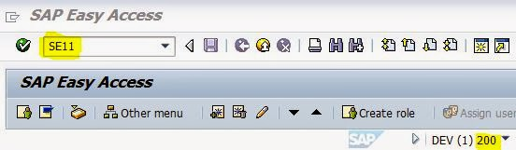](https://sapcodes.com/wp-content/uploads/2015/11/e8f91-1.jpg)**

**Step2. Provide the table name and click on create button.**

**[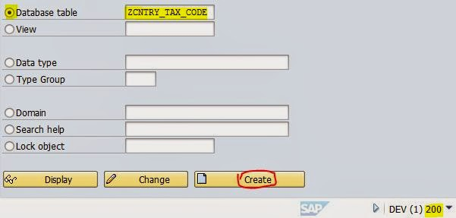](https://sapcodes.com/wp-content/uploads/2015/11/ffefc-2.jpg)**

**Step3. Provide the detail fields and activate the table. Create some records.**

**[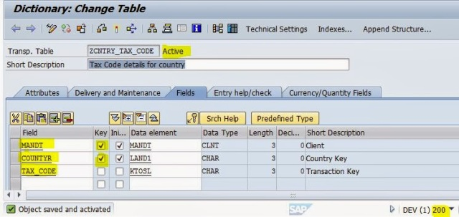](https://sapcodes.com/wp-content/uploads/2015/11/49d87-3.jpg)**

**Step4. The records of the table are displayed below.**

**[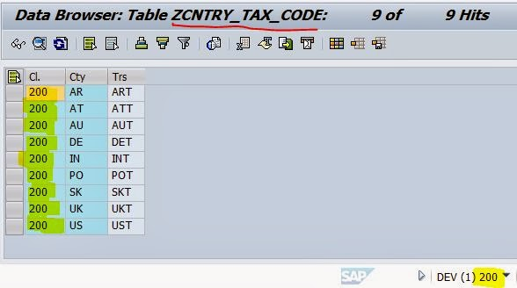](https://sapcodes.com/wp-content/uploads/2015/11/af6d5-4.jpg)**

**Step5. The same table is available in the client 300.**

**[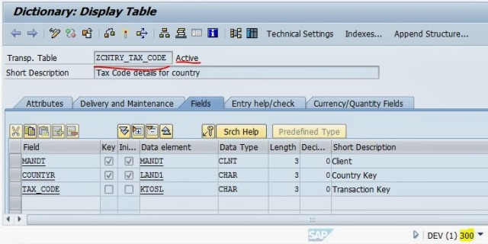](https://sapcodes.com/wp-content/uploads/2015/11/5c997-5.jpg)**

**Step6. There are no records present in the table for the client 300.**

**[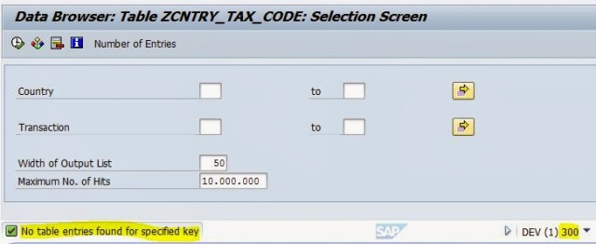](https://sapcodes.com/wp-content/uploads/2015/11/8ea68-6.jpg)**

**Step7. Go to Tcode- SALE.**

**[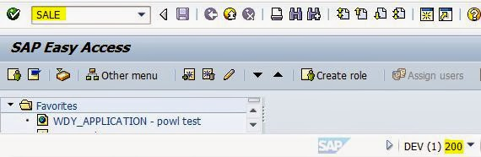](https://sapcodes.com/wp-content/uploads/2015/11/c812b-7.jpg)**

**Step8. Navigate along the highlighted path to create logical systems.**

**[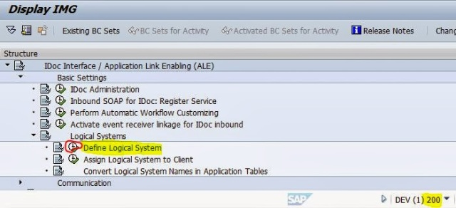](https://sapcodes.com/wp-content/uploads/2015/11/201fe-8.jpg)**

**Step9. Create two logical systems for the client 200 and 300.**

**[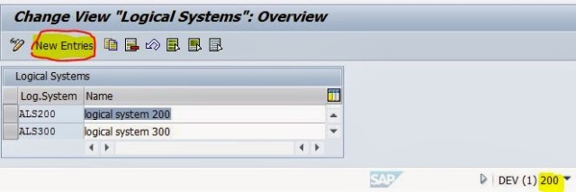](https://sapcodes.com/wp-content/uploads/2015/11/69b6c-9.jpg)**

**Step10. Save it and click on the BACK button.**

**[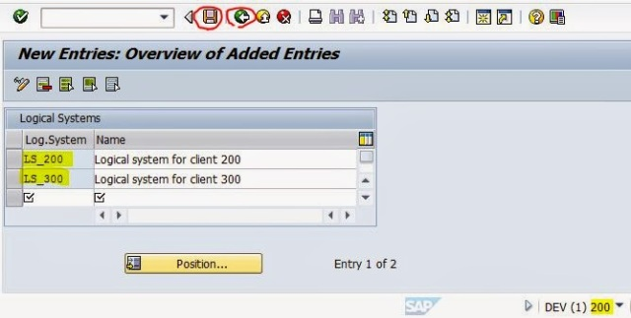](https://sapcodes.com/wp-content/uploads/2015/11/a7d91-10.jpg)**

**Step11. Click on the highlighted line to assign the logical systems to the clients.**

**[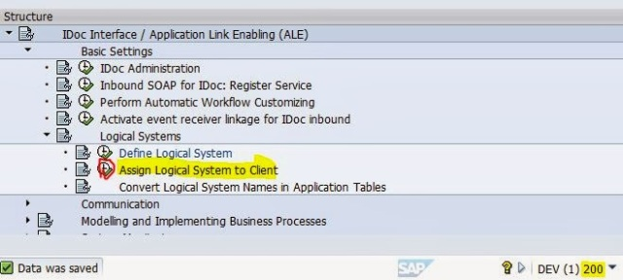](https://sapcodes.com/wp-content/uploads/2015/11/1e58e-11.jpg)**

**Step12. Double  Click on the client-200.**

**[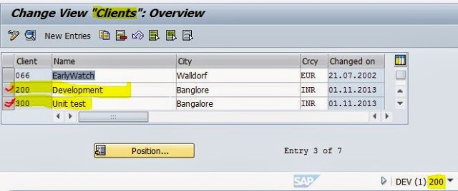](https://sapcodes.com/wp-content/uploads/2015/11/f9b5b-12.jpg)**

**Step13. Maintain the logical system , click on save and then click on  Back button. Then double click on client 300.**

**[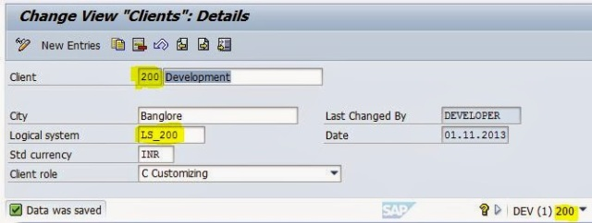](https://sapcodes.com/wp-content/uploads/2015/11/6707c-13.jpg)**

**Step14. Provide the logical system for the client 300, save it and at last click on Back button.**

**[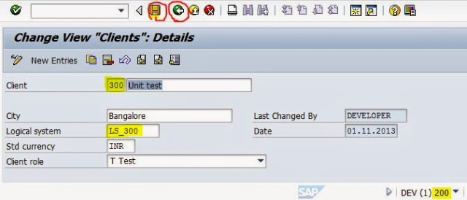](https://sapcodes.com/wp-content/uploads/2015/11/8bf68-14.jpg)**

**Step15. Click on the highlighted line to create rfc destination or go to tcode- SM59.**

**[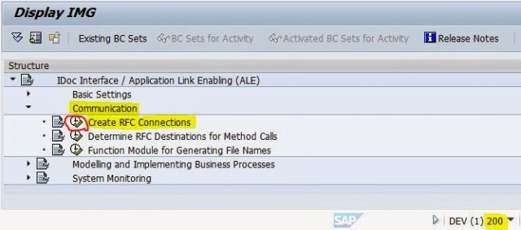](https://sapcodes.com/wp-content/uploads/2015/11/be78d-15.jpg)**

**Step16. Select the ABAP Connection type and click on Create Button.**

**[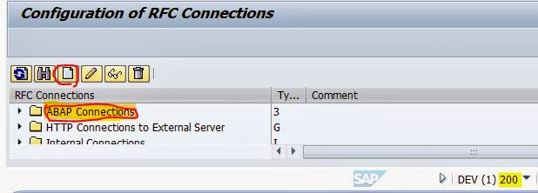](https://sapcodes.com/wp-content/uploads/2015/11/ab122-16.jpg)**

**Step17. Provide the details and save it. Click on the connection the button.**

**[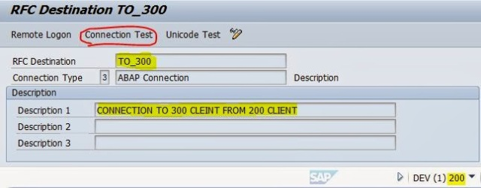](https://sapcodes.com/wp-content/uploads/2015/11/1de42-17.jpg)**

**Step18. The connection works fine.**

**[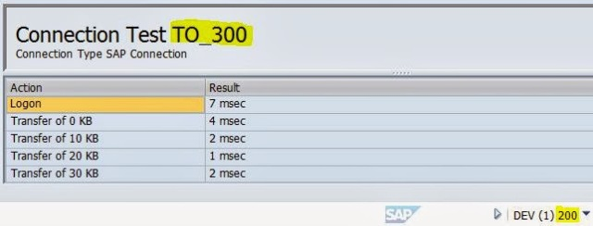](https://sapcodes.com/wp-content/uploads/2015/11/921e6-18.jpg)**

**Step19. Now logon to the 300 client and create a rfc destination. Provide the details, save it and at last click on Connection Test button.**

**[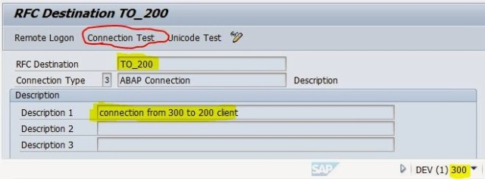](https://sapcodes.com/wp-content/uploads/2015/11/7c69f-19.jpg)**

**Step20. The RFC connection works fine.**

**[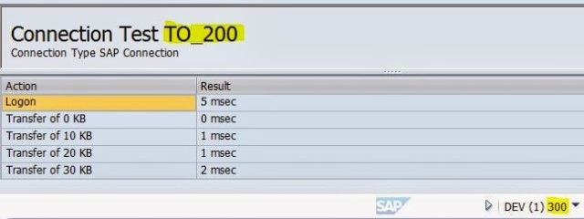](https://sapcodes.com/wp-content/uploads/2015/11/7bc79-20.jpg)**

**Step21. Now go to Tcode- WE21 to create port.**

**[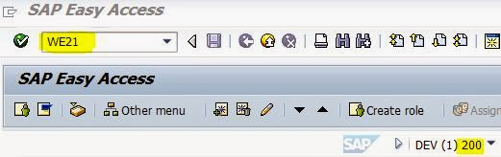](https://sapcodes.com/wp-content/uploads/2015/11/436af-21-1.jpg)**

**Step22. Select the transactional RFC line and click on the create button.**

**[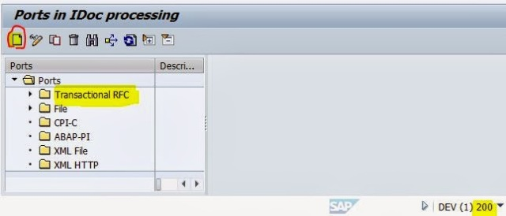](https://sapcodes.com/wp-content/uploads/2015/11/6748e-21.jpg)**

**Step23. Select the first line and click on continue button.**

**[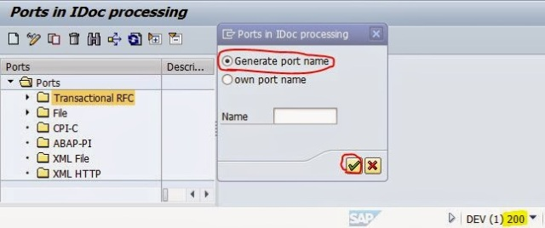](https://sapcodes.com/wp-content/uploads/2015/11/a8e16-22.jpg)**

**Step24. The system automatically creates a port number, provide the description and the RFC destination name and save it.**

**[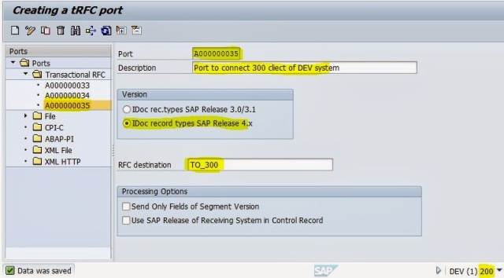](https://sapcodes.com/wp-content/uploads/2015/11/f0237-23.jpg)**

**Step25. Now go to client 300. Go to Tcode- WE21.**

**[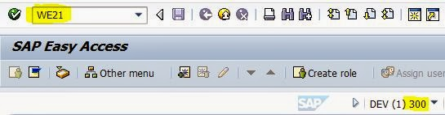](https://sapcodes.com/wp-content/uploads/2015/11/f0c1c-24.jpg)**

**Step26. Select the transactional RFC line and click on the create button.**

**[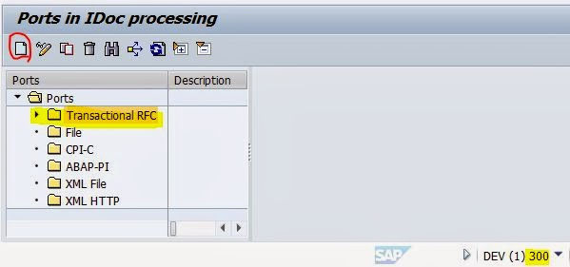](https://sapcodes.com/wp-content/uploads/2015/11/58376-25.jpg)**

**Step27. Select the first line and click on continue button.**

**[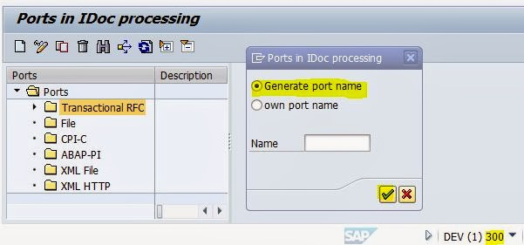](https://sapcodes.com/wp-content/uploads/2015/11/1b990-26.jpg)**

**Step28. The system automatically creates a port number, provide the description and the RFC destination name and save it.**

**[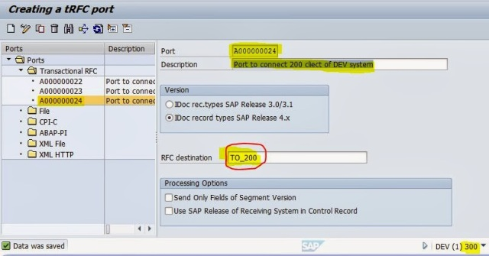](https://sapcodes.com/wp-content/uploads/2015/11/fe02e-27.jpg)**

**Step29. Now in client-200 , go to Tcode- WE31.**

**[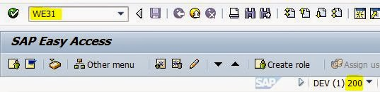](https://sapcodes.com/wp-content/uploads/2015/11/ee53b-28.jpg)**

**Step30. Provide the segment name and click on the create button.**

**[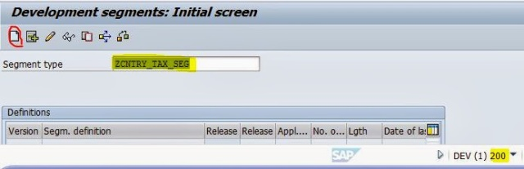](https://sapcodes.com/wp-content/uploads/2015/11/00047-29.jpg)**

**Step31. Provide the short text, the fields of the table with data element and click on the save button.**

**[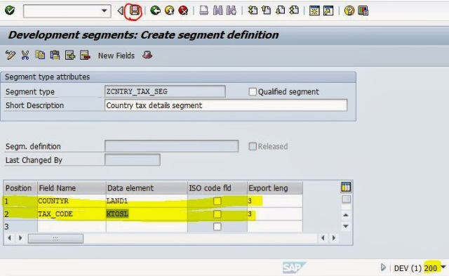](https://sapcodes.com/wp-content/uploads/2015/11/bcf56-30.jpg)**

**Step32. Click the continue button.**

**[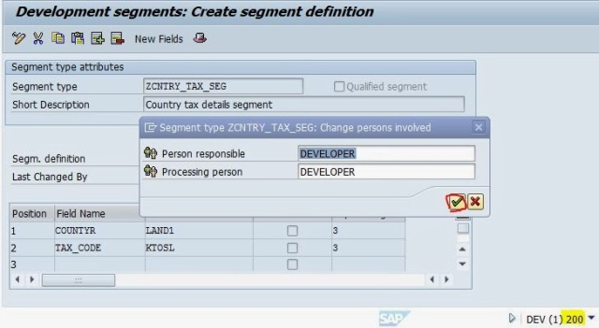](https://sapcodes.com/wp-content/uploads/2015/11/22a26-31.jpg)**

**Step33. Save it and click on Back button.**

**[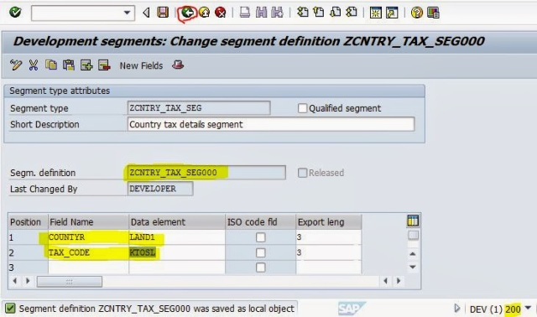](https://sapcodes.com/wp-content/uploads/2015/11/9acf0-32.jpg)**

**Step34. Again click on Back button.**

**[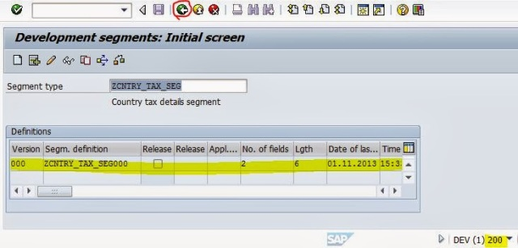](https://sapcodes.com/wp-content/uploads/2015/11/f2e3a-33.jpg)**

**Step35. Now go to Tcode- SE11.**

**[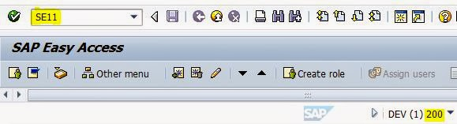](https://sapcodes.com/wp-content/uploads/2015/11/99d06-34.jpg)**

**Step36.  Provide the segment name and click on display button.**

**[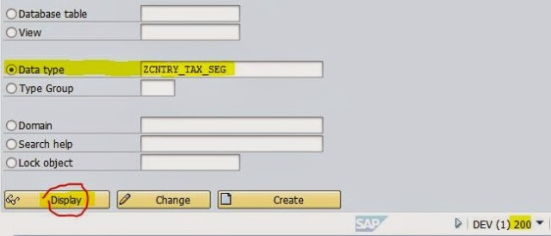](https://sapcodes.com/wp-content/uploads/2015/11/683cd-35.jpg)**

**Step37. The system automatically creates a structure with the name of the segment.**

**[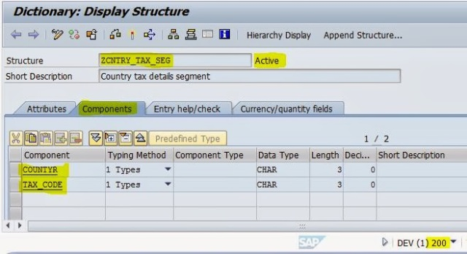](https://sapcodes.com/wp-content/uploads/2015/11/bfebd-36.jpg)**

**Step38. Now go to Tcode- WE30 to asisgn the segment the the IDOC type.**

**[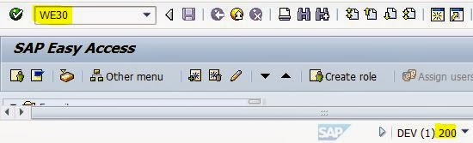](https://sapcodes.com/wp-content/uploads/2015/11/fb571-37.jpg)**

**Step39. Provide the IDOC type name and click on Create button.**

**[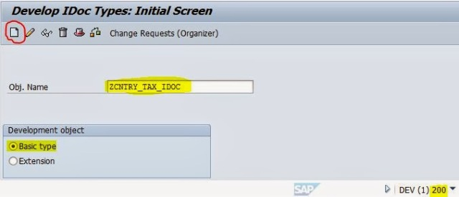](https://sapcodes.com/wp-content/uploads/2015/11/d0871-38.jpg)**

**Step40. Select the create New radio button and provide the description and click on continue button.**

**[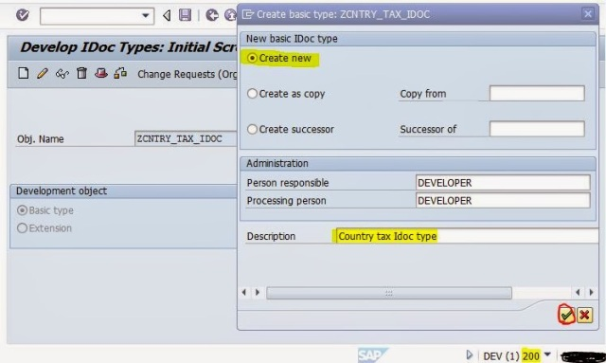](https://sapcodes.com/wp-content/uploads/2015/11/399f3-39.jpg)**

**Step41. Select the Idoc type and click on the Create button.**

**[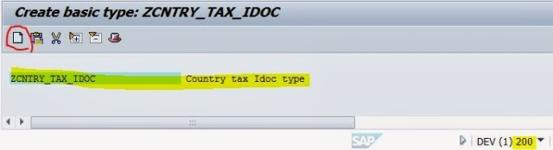](https://sapcodes.com/wp-content/uploads/2015/11/26253-40.jpg)**

**Step42.  Provide the segment name created above. Select it as Mandatory segment and at last click on the Continue button.**

**[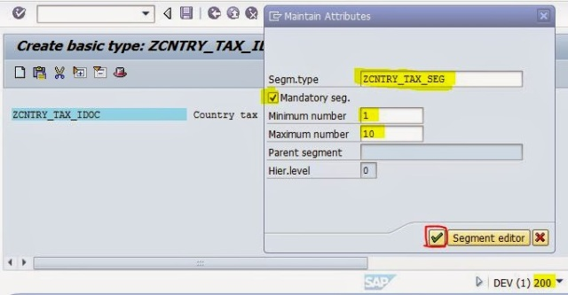](https://sapcodes.com/wp-content/uploads/2015/11/35312-41.jpg)**

**Step43. Now click on the Edit menu and Click Set Release .**

**[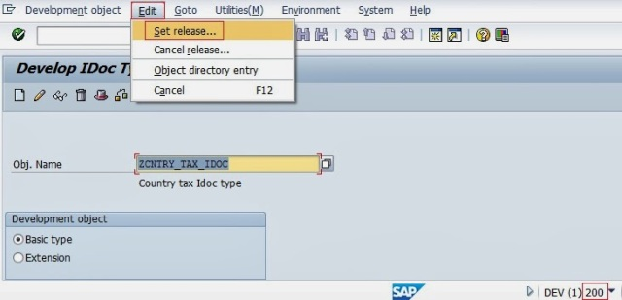](https://sapcodes.com/wp-content/uploads/2015/11/40996-42-1.jpg)**

**Step44. Click on Yes button to continue.**

**[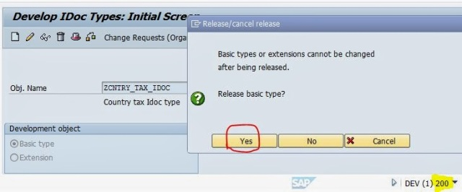](https://sapcodes.com/wp-content/uploads/2015/11/a93b1-42-2.jpg)**

**Step45. Save it and click on Back button,**

**[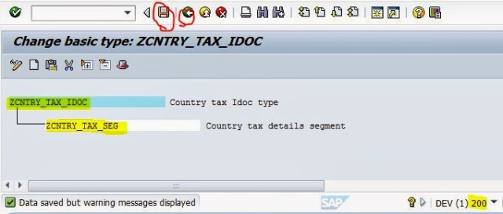](https://sapcodes.com/wp-content/uploads/2015/11/ccbd0-42.jpg)**

**Step46. Now go to Tcode- SE81 to create a message type.**

**[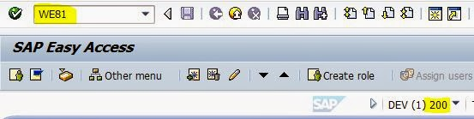](https://sapcodes.com/wp-content/uploads/2015/11/aa9da-43.jpg)**

**Step47. Click on Edit and the New Entries button.**

**[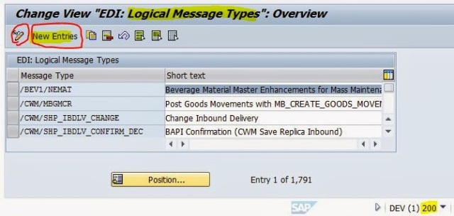](https://sapcodes.com/wp-content/uploads/2015/11/a5970-44.jpg)**

**Step48. Provide a message type and short text and save it. At last click on Back button.**

**[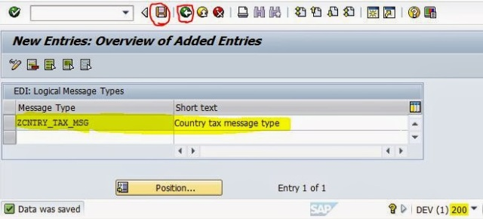](https://sapcodes.com/wp-content/uploads/2015/11/87ef3-45.jpg)**

**Step49. Now go to Tcode- WE82 to assign message type to Idoc.**

**[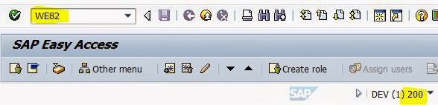](https://sapcodes.com/wp-content/uploads/2015/11/c1c80-46.jpg)**

**Step50. Click on the Edit button.**

**[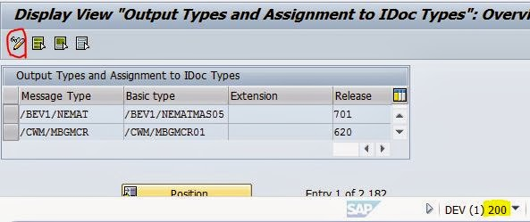](https://sapcodes.com/wp-content/uploads/2015/11/97b00-47.jpg)**

**Step51. Click on New Entries button.**

**[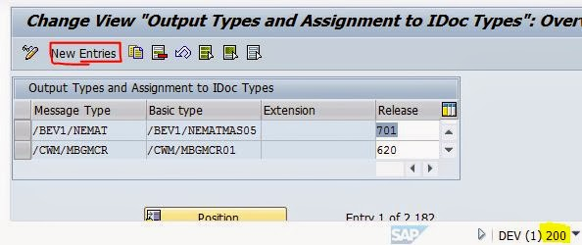](https://sapcodes.com/wp-content/uploads/2015/11/27c2d-48.jpg)**

**Step52. Provide the above created message type, Idoc name and release and Save it. At last click on Back button.**

**[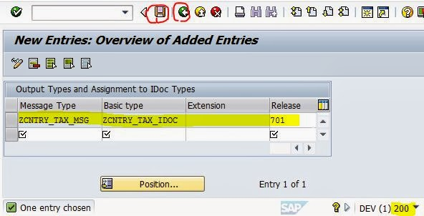](https://sapcodes.com/wp-content/uploads/2015/11/173a2-49.jpg)**

**Step53. Now go to Tcode- BD64 to create Customer Distribution Model.**

**[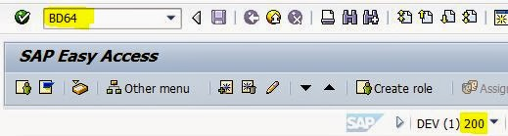](https://sapcodes.com/wp-content/uploads/2015/11/1e1bc-50.jpg)**

**Step54. Click on Edit button.**

**[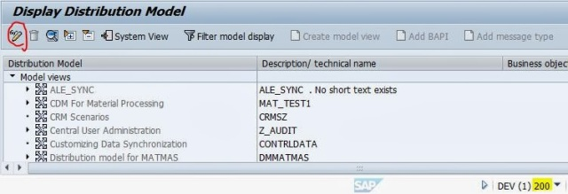](https://sapcodes.com/wp-content/uploads/2015/11/aface-51.jpg)**

**Step55. Now click on Create Model view.**

**[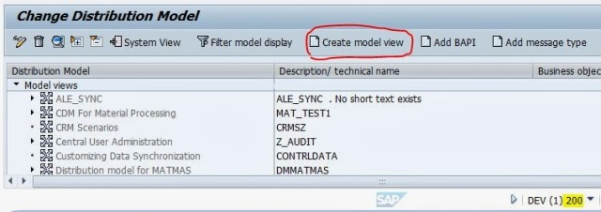](https://sapcodes.com/wp-content/uploads/2015/11/8b734-52.jpg)**

**Step56. Provide Technical name, short text and click on Continue button.**

**[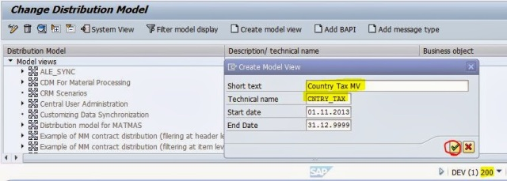](https://sapcodes.com/wp-content/uploads/2015/11/29ac6-53.jpg)**

**Step57. Now click on Add Message Type button.**

**[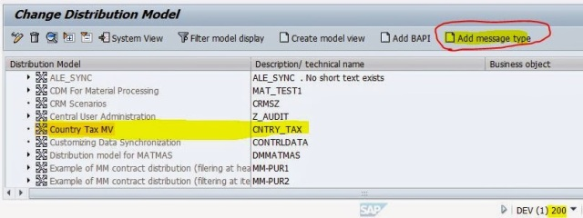](https://sapcodes.com/wp-content/uploads/2015/11/8869e-54.jpg)**

**Step58. Provide the sender logical system, receiver logical system, message type and click on Yes button.**

**[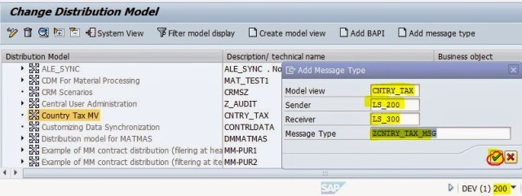](https://sapcodes.com/wp-content/uploads/2015/11/4d687-55.jpg)**

**Step59. Now the Customer Distribution model looks like as shown below.**

**[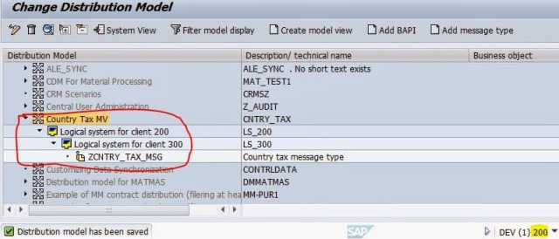](https://sapcodes.com/wp-content/uploads/2015/11/b7e6a-56.jpg)**

**Step60. Select the distribution model and from the Environment menu click on generate partner profiles.**

**[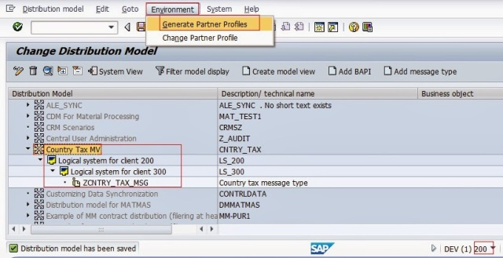](https://sapcodes.com/wp-content/uploads/2015/11/605a1-57.jpg)**

**Step61. Execute the program.**

**[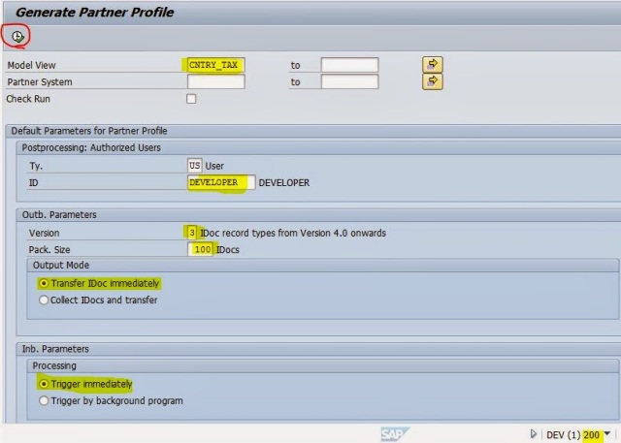](https://sapcodes.com/wp-content/uploads/2015/11/5f95d-58.jpg)**

**Step62. It generates the partner profiles LS_300 and LS_200.**

**[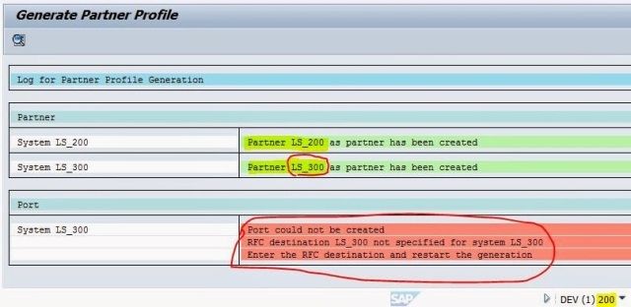](https://sapcodes.com/wp-content/uploads/2015/11/ca825-59.jpg)**

**Step63. Lets go to the Tcode WE20 to edit the generated partner profiles.**

**[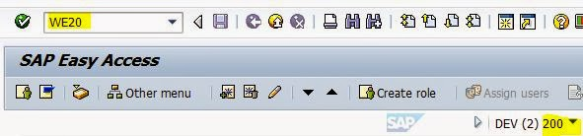](https://sapcodes.com/wp-content/uploads/2015/11/84be4-60.jpg)**

**Step64. Under the partner type LS, select the LS_300. Click on  the Add button as highlighted under Outbound Parameters.**

**[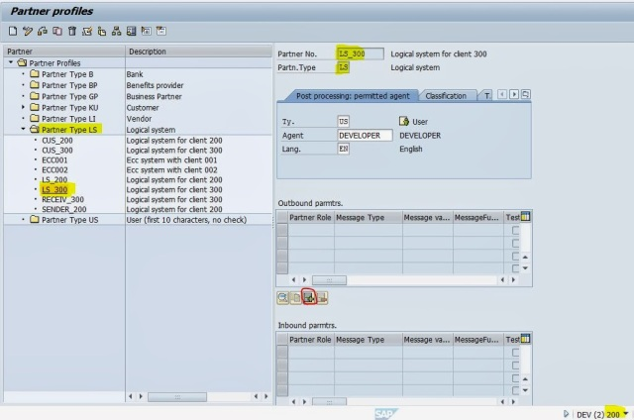](https://sapcodes.com/wp-content/uploads/2015/11/79ff4-61.jpg)**

**Step65. Provide the message type, port and Idoc type, save it and click on back button.**

**[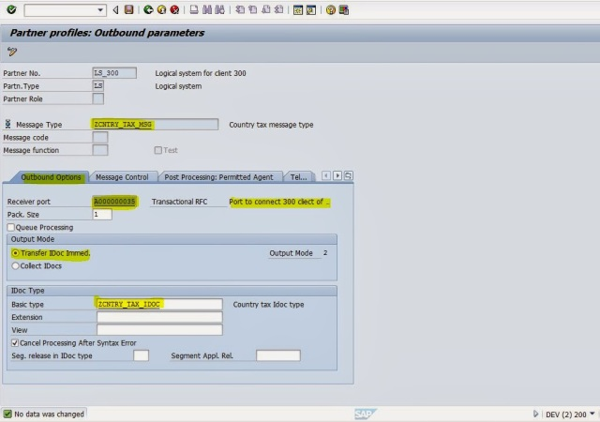](https://sapcodes.com/wp-content/uploads/2015/11/f86b9-62.jpg)**

**Step66. Now the message type is added under the outbound parameter.**

**[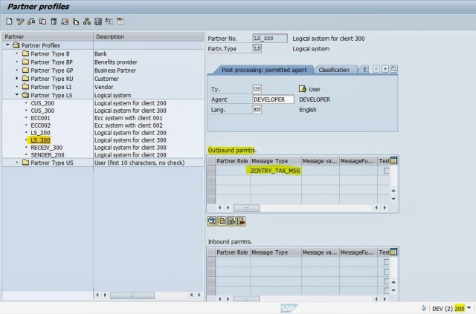](https://sapcodes.com/wp-content/uploads/2015/11/6cd77-63.jpg)**

**Step67. Go to Tcode- BD64, select the customer distribution model and from the environment menu click on Generate Partner profile.**

**[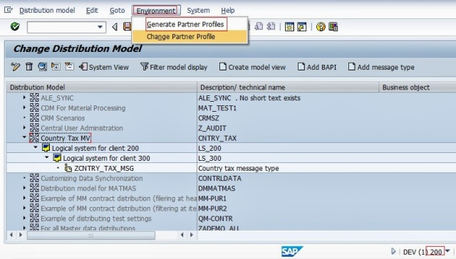](https://sapcodes.com/wp-content/uploads/2015/11/e5863-64.jpg)**

**Step68. Execute the below program.**

**[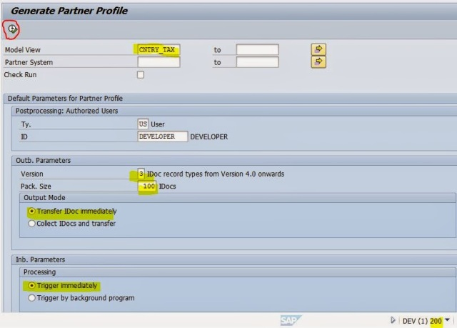](https://sapcodes.com/wp-content/uploads/2015/11/c773a-65.jpg)**

**Step69. There is no red line. So all teh set up is fine.**

**[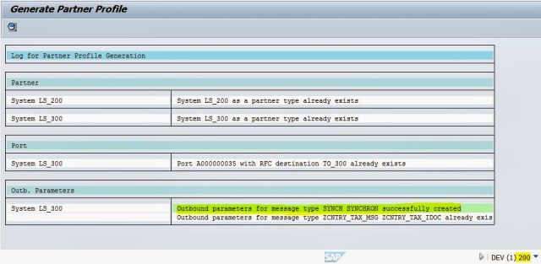](https://sapcodes.com/wp-content/uploads/2015/11/3a9ff-66.jpg)**

**Step70. Now go to Tcode – We20 to see again the partner profile.  The SYNCH message type is automatically added to the partner profile LS_300 when it is generated. Now double click on teh message type SYNCH.**

Advertisement

**[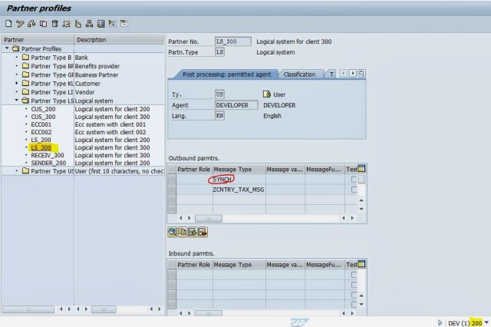](https://sapcodes.com/wp-content/uploads/2015/11/e0452-67.jpg)**

**Step71.  The port and other details are automatically automatically assigned. Save it and go back.**

**[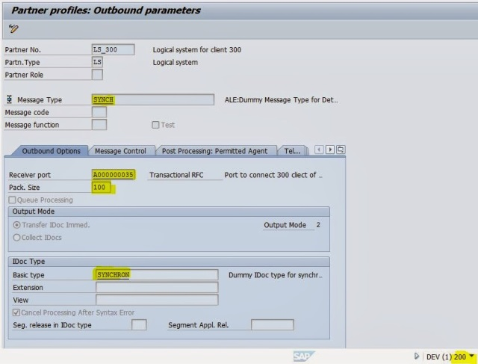](https://sapcodes.com/wp-content/uploads/2015/11/e4fb7-68.jpg)**

**Step72. Now go to teh tcode- BD64, Select the Customer distribution model and Navigate along the highlighted path to distribute the Distribution model.**

**[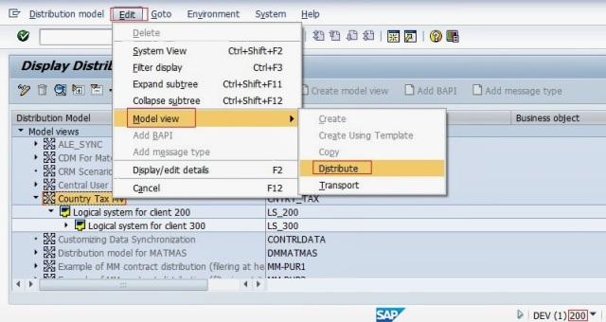](https://sapcodes.com/wp-content/uploads/2015/11/2abe1-69.jpg)**

**Step73. Select the receiver model view as LS_300.**

**[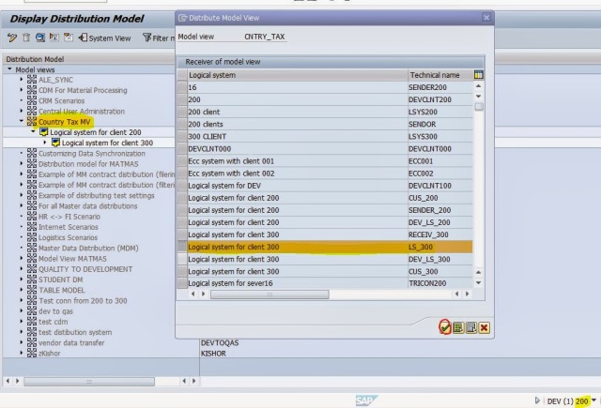](https://sapcodes.com/wp-content/uploads/2015/11/a5e86-70.jpg)**

**Step74. Now the distribution model is created in the target client (300).**

**[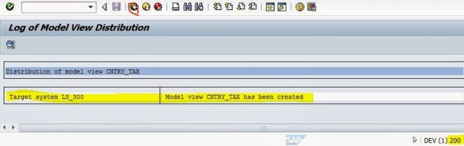](https://sapcodes.com/wp-content/uploads/2015/11/fa88e-71.jpg)**

**Step75. Now go to Tcode- SE38.**

**[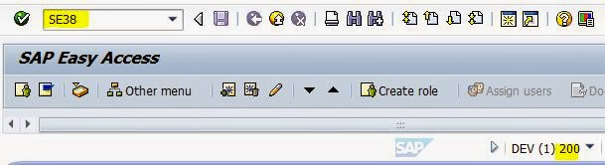](https://sapcodes.com/wp-content/uploads/2015/11/42f00-72.jpg)**

**Step76. Provide a report name and create  it.**

**[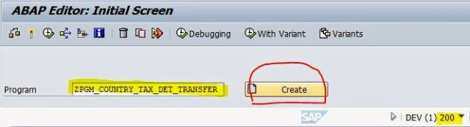](https://sapcodes.com/wp-content/uploads/2015/11/0bb42-73.jpg)**

**Step77. Provide the below code and activate it.**

**[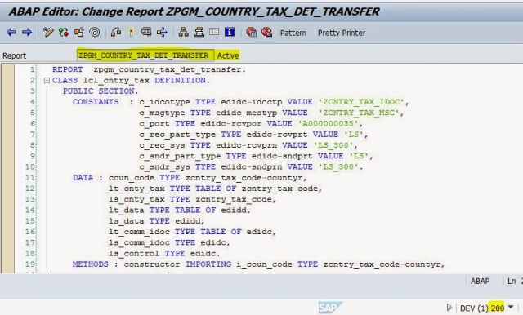](https://sapcodes.com/wp-content/uploads/2015/11/65b0c-74.jpg)**

**REPORT  zpgm_country_tax_det_transfer.**

**CLASS lcl_cntry_tax DEFINITION.**

**PUBLIC SECTION.**

**CONSTANTS  : c_idcotype TYPE edidc-idoctp VALUE ‘ZCNTRY_TAX_IDOC’,**

**c_msgtype TYPE edidc-mestyp VALUE  ‘ZCNTRY_TAX_MSG’,**

**c_port TYPE edidc-rcvpor VALUE ‘A000000035’,**

**c_rec_part_type TYPE edidc-rcvprt VALUE ‘LS’,**

**c_rec_sys TYPE edidc-rcvprn VALUE ‘LS_300’,**

**c_sndr_part_type TYPE edidc-sndprt VALUE ‘LS’,**

**c_sndr_sys TYPE edidc-sndprn VALUE ‘LS_300’.**

**DATA : coun_code TYPE zcntry_tax_code-countyr,**

**lt_cnty_tax TYPE TABLE OF zcntry_tax_code,**

**ls_cnty_tax TYPE zcntry_tax_code,**

**lt_data TYPE TABLE OF edidd,**

**ls_data TYPE edidd,**

**lt_comm_idoc TYPE TABLE OF edidc,**

**ls_comm_idoc TYPE edidc,**

**ls_control TYPE edidc.**

**METHODS : constructor IMPORTING i_coun_code TYPE zcntry_tax_code-countyr,**

**prepare_data,**

**prepare_cntl_data,**

**send_idoc.**

**ENDCLASS.                    “lcl_cntry_tax DEFINITION**

**CLASS lcl_cntry_tax IMPLEMENTATION.**

**METHOD constructor.**

**coun_code = i_coun_code.**

**ENDMETHOD.                    “constructor**

**METHOD prepare_data.**

**DATA : ls_seg TYPE zcntry_tax_seg.**

**SELECT  * FROM zcntry_tax_code INTO TABLE  lt_cnty_tax WHERE countyr = coun_code.**

**IF sy-subrc = 0.**

**LOOP AT lt_cnty_tax INTO ls_cnty_tax.**

**ls_data-segnam  = ‘ZCNTRY_TAX_SEG’. ” segment name**

**ls_seg-countyr = ls_cnty_tax-countyr.**

**ls_seg-tax_code = ls_cnty_tax-tax_code.**

**ls_data-sdata = ls_seg.**

**APPEND ls_data TO lt_data.**

**CLEAR ls_data.**

**ENDLOOP.**

**ELSE.**

**MESSAGE ‘No record found’ TYPE ‘E’.**

**ENDIF.**

**ENDMETHOD.                    “prepare_data**

**METHOD prepare_cntl_data.**

**ls_control-idoctp = c_idcotype.**

**ls_control-mestyp = c_msgtype.**

**ls_control-rcvpor = c_port.**

**ls_control-rcvprt = c_rec_part_type .**

**ls_control-rcvprn = c_rec_sys.**

**ls_control-sndprt = c_sndr_part_type .**

**ls_control-sndprn = c_sndr_sys.**

**ENDMETHOD.                    “prepare_cntl_data**

**METHOD send_idoc.**

**CALL FUNCTION ‘MASTER_IDOC_DISTRIBUTE’**

**EXPORTING**

**master_idoc_control            = ls_control**

**\*       OBJ_TYPE                       = ”**

**\*       CHNUM                          = ”**

**TABLES**

**communication_idoc_control     = lt_comm_idoc**

**master_idoc_data               = lt_data**

**EXCEPTIONS**

**error_in_idoc_control          = 1**

**error_writing_idoc_status      = 2**

**error_in_idoc_data             = 3**

**sending_logical_system_unknown = 4**

**OTHERS                         = 5.**

**IF sy-subrc = 0.**

**LOOP AT lt_comm_idoc INTO ls_comm_idoc.**

**WRITE  ‘Idoc Generated : ‘, ls_comm_idoc-docnum.**

**ENDLOOP.**

**ENDIF.**

**ENDMETHOD.                    “send_idoc**

**ENDCLASS.                    “lcl_cntry_tax IMPLEMENTATION**

**START-OF-SELECTION.**

**PARAMETERS : p_cntry TYPE zcntry_tax_code-countyr.**

**DATA  : obj TYPE REF TO lcl_cntry_tax.**

**CREATE OBJECT obj**

**EXPORTING**

**i_coun_code = p_cntry.**

**CALL METHOD obj->prepare_data.**

**CALL METHOD obj->prepare_cntl_data.**

**CALL METHOD obj->send_idoc.**

**Step78. All the set up with the custom report in the source client 200 is ready. Now logon to the client 300. Go to Tcode- SE80.**

**[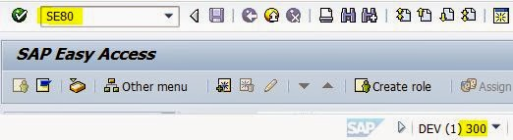](https://sapcodes.com/wp-content/uploads/2015/11/0007f-75.jpg)**

**Step79.  Create a function group. Provide the name and hit the enter button. From the popup click on Yes button.**

**[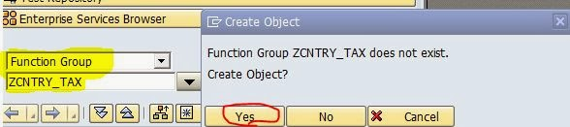](https://sapcodes.com/wp-content/uploads/2015/11/380b6-76.jpg)**

**Step80. Activate the Function Group.**

**[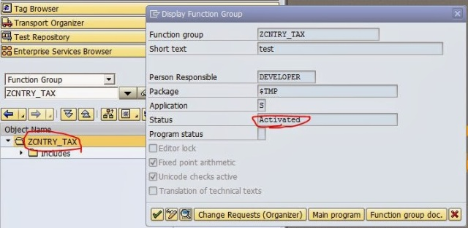](https://sapcodes.com/wp-content/uploads/2015/11/de441-77.jpg)**

**Step81. Now go to Tcode- SE37 .**

**[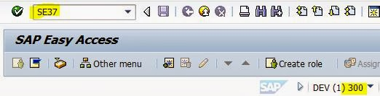](https://sapcodes.com/wp-content/uploads/2015/11/f47e2-78.jpg)**

**Step82. Now Provide a function module name and click on the create button.**

**[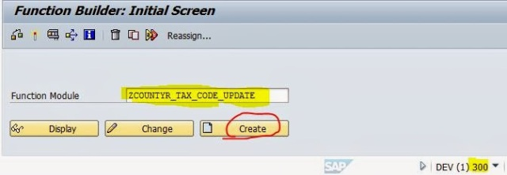](https://sapcodes.com/wp-content/uploads/2015/11/b2db3-79.jpg)**

**Step83. Provide the above created function group name and description and click on Save button.**

**[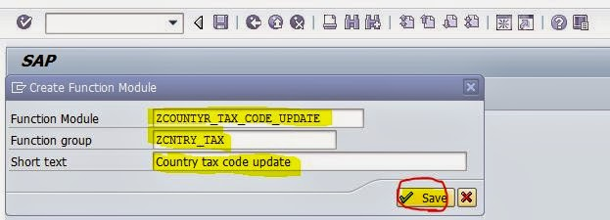](https://sapcodes.com/wp-content/uploads/2015/11/ee51e-80.jpg)**

**Step84. Provide the Importing parameters as shown below.**

**[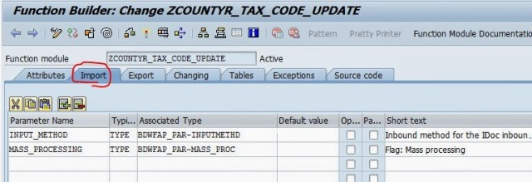](https://sapcodes.com/wp-content/uploads/2015/11/262c1-fm1.jpg)**

**Step85.  Provide the Exporting parameters as shown below.**

**[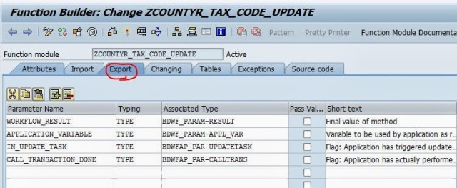](https://sapcodes.com/wp-content/uploads/2015/11/fe146-fm2.jpg)**

**Step86.  Provide the parameters under the Tables section as shown below.**

**[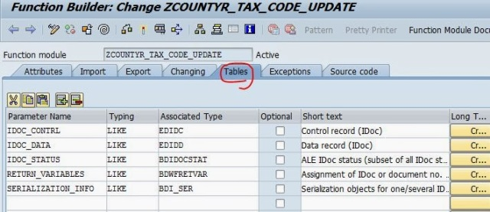](https://sapcodes.com/wp-content/uploads/2015/11/2c8bd-fm3.jpg)**

**Step87.  Provide the Exception as shown below.**

**[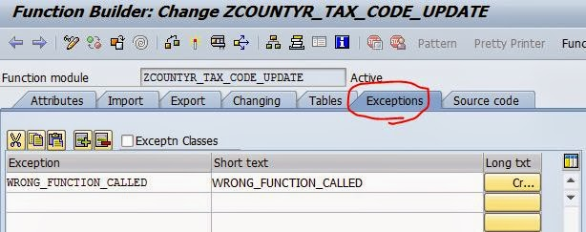](https://sapcodes.com/wp-content/uploads/2015/11/bc95f-fm5.jpg)**

**Step88. Maintain the below code.**

**[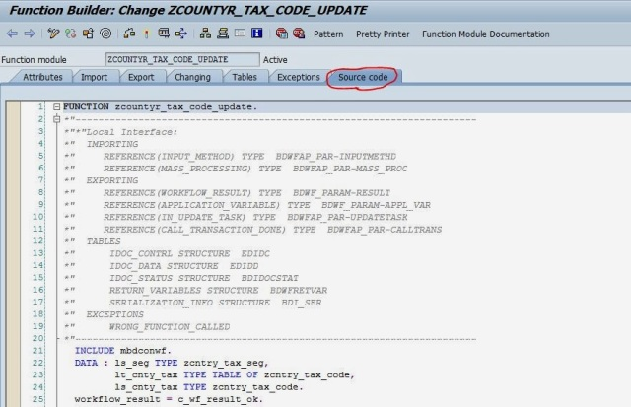](https://sapcodes.com/wp-content/uploads/2015/11/e26c8-fm6.jpg)**

**FUNCTION zcountyr_tax_code_update.**

**\*”———————————————————————-**

**\*”*”Local Interface:**

**\*”  IMPORTING**

**\*”     REFERENCE(INPUT_METHOD) TYPE  BDWFAP_PAR-INPUTMETHD**

**\*”     REFERENCE(MASS_PROCESSING) TYPE  BDWFAP_PAR-MASS_PROC**

**\*”  EXPORTING**

**\*”     REFERENCE(WORKFLOW_RESULT) TYPE  BDWF_PARAM-RESULT**

**\*”     REFERENCE(APPLICATION_VARIABLE) TYPE  BDWF_PARAM-APPL_VAR**

**\*”     REFERENCE(IN_UPDATE_TASK) TYPE  BDWFAP_PAR-UPDATETASK**

**\*”     REFERENCE(CALL_TRANSACTION_DONE) TYPE  BDWFAP_PAR-CALLTRANS**

**\*”  TABLES**

**\*”      IDOC_CONTRL STRUCTURE  EDIDC**

**\*”      IDOC_DATA STRUCTURE  EDIDD**

**\*”      IDOC_STATUS STRUCTURE  BDIDOCSTAT**

**\*”      RETURN_VARIABLES STRUCTURE  BDWFRETVAR**

**\*”      SERIALIZATION_INFO STRUCTURE  BDI_SER**

**\*”  EXCEPTIONS**

**\*”      WRONG_FUNCTION_CALLED**

**\*”———————————————————————-**

**INCLUDE mbdconwf.**

**DATA : ls_seg TYPE zcntry_tax_seg,**

**lt_cnty_tax TYPE TABLE OF zcntry_tax_code,**

**ls_cnty_tax TYPE zcntry_tax_code.**

**workflow_result = c_wf_result_ok.**

**LOOP AT idoc_contrl.**

**IF idoc_contrl-mestyp = ‘ZCNTRY_TAX_MSG’.**

**LOOP AT  idoc_data.**

**ls_seg = idoc_data-sdata.**

**MOVE-CORRESPONDING ls_seg TO ls_cnty_tax.**

**APPEND ls_cnty_tax TO lt_cnty_tax.**

**ENDLOOP.**

**MODIFY zcntry_tax_code FROM TABLE lt_cnty_tax.**

**IF sy-subrc = 0.**

**idoc_status-docnum = idoc_contrl-docnum.**

**idoc_status-status = ’53’.**

**idoc_status-msgv1 =  ls_cnty_tax-countyr.**

**APPEND idoc_status.**

**CLEAR idoc_status.**

**ELSE.**

**idoc_status-docnum = idoc_contrl-docnum.**

**idoc_status-status = ’51’.**

**idoc_status-msgv1 =  ls_cnty_tax-countyr.**

**APPEND idoc_status.**

**CLEAR idoc_status.**

**workflow_result = c_wf_result_error.**

**return_variables-wf_param = ‘Error_Idocs’.**

**return_variables-doc_number = idoc_contrl-docnum.**

**APPEND return_variables.**

**CLEAR return_variables.**

**ENDIF.**

**ENDIF.**

**ENDLOOP.**

**ENDFUNCTION.**

**Step89. Now go to Tcode- WE57 to assign the Function module to the Idoc type.**

**[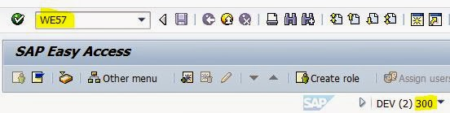](https://sapcodes.com/wp-content/uploads/2015/11/51054-83.jpg)**

**Step90. Click on Edit button.**

**[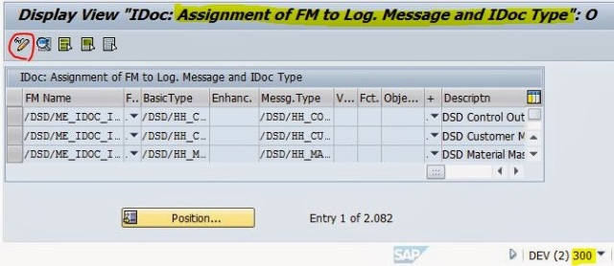](https://sapcodes.com/wp-content/uploads/2015/11/7cbbc-84.jpg)**

**Step91. Clcik on New Entries.**

**[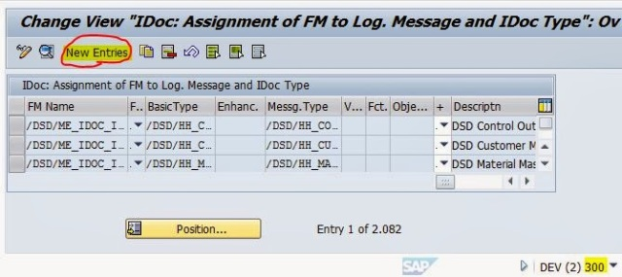](https://sapcodes.com/wp-content/uploads/2015/11/1c011-85.jpg)**

**Step92. Provide the Function module name, Idoc name and message type. Save it and clcik on back button.**

**[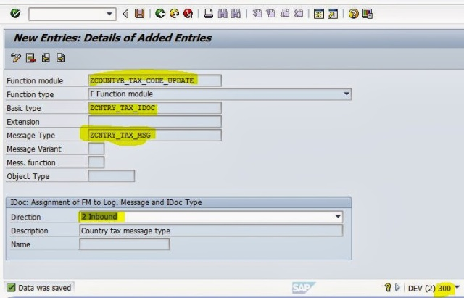](https://sapcodes.com/wp-content/uploads/2015/11/bd130-86.jpg)**

**Step93. The line appears in the list.**

**[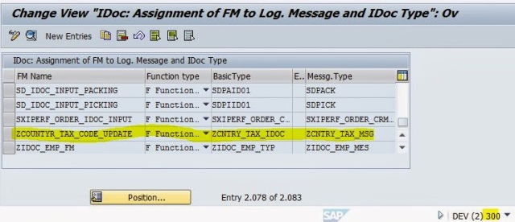](https://sapcodes.com/wp-content/uploads/2015/11/a04d2-87.jpg)**

**Step94. Now go to Tcode- BD51 .**

**[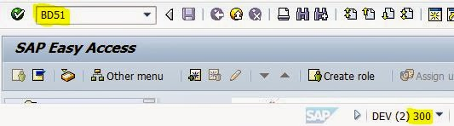](https://sapcodes.com/wp-content/uploads/2015/11/00703-88.jpg)**

**Step95. click On New Entries.**

**[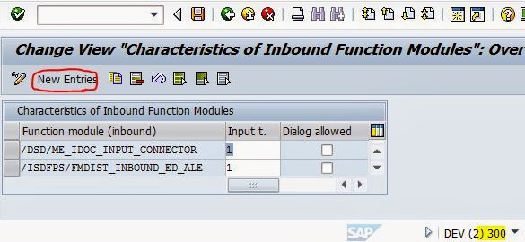](https://sapcodes.com/wp-content/uploads/2015/11/5d8f0-89.jpg)**

**Step96. Provide the Function Module name and maintain value as 2 under input section as a inbound function module.**

**[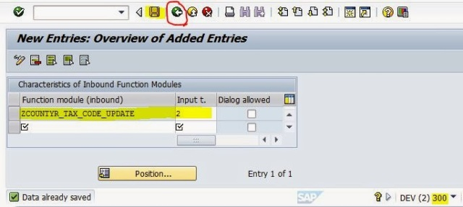](https://sapcodes.com/wp-content/uploads/2015/11/8d2d0-90.jpg)**

**Step97. Now go to Tcode- WE42.**

**[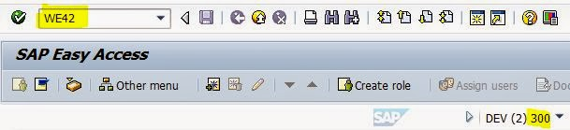](https://sapcodes.com/wp-content/uploads/2015/11/f5b91-91.jpg)**

**Step98. Click on Edit button.**

**[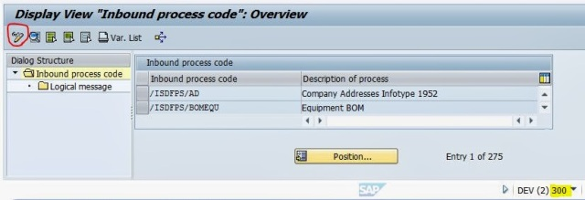](https://sapcodes.com/wp-content/uploads/2015/11/a0363-92.jpg)**

**Step99. Click on New Entries button.**

**[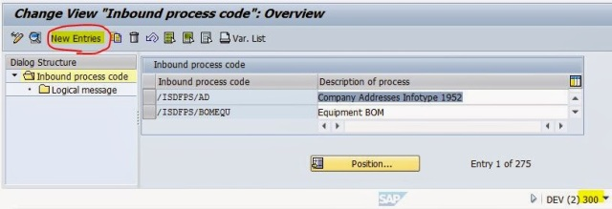](https://sapcodes.com/wp-content/uploads/2015/11/f0c2a-93.jpg)**

**Step100. Provide a Processing Code name with description. Select the radio buttons as highlighted below. Save it and click on back button.**

**[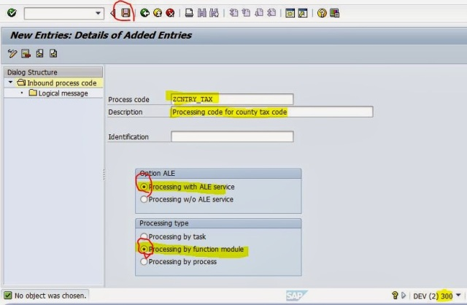](https://sapcodes.com/wp-content/uploads/2015/11/a6154-94.jpg)**

**Step101. Here provide the Inbound function module name, save it and click on Back button.**

**[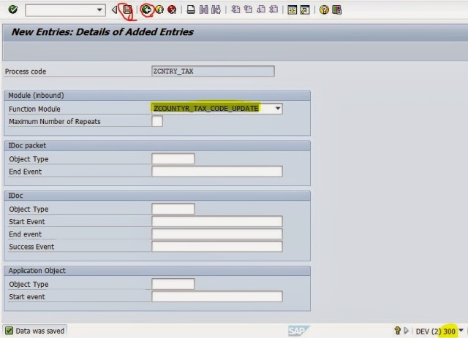](https://sapcodes.com/wp-content/uploads/2015/11/6f6a9-95.jpg)**

**Step102. Now double click on the logical message  line highlighted in the left hand side.**

**[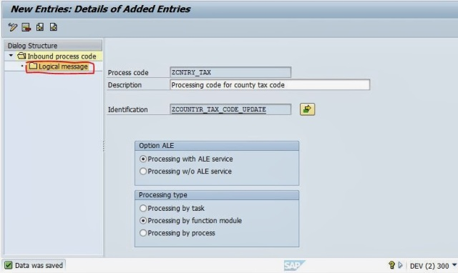](https://sapcodes.com/wp-content/uploads/2015/11/5db65-96.jpg)**

**Step103. Click on New Entries button.**

**[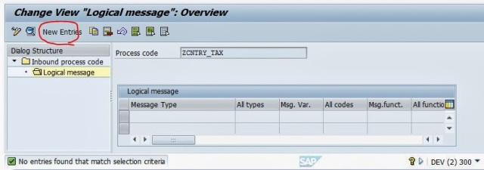](https://sapcodes.com/wp-content/uploads/2015/11/1e02c-97.jpg)**

**Step104. Provide the message type name, save it and click on the Back button.**

**[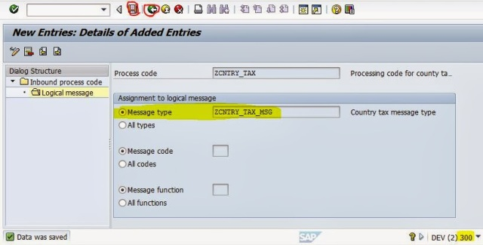](https://sapcodes.com/wp-content/uploads/2015/11/c1c79-98.jpg)**

**Step105. Click on the Back button.**

**[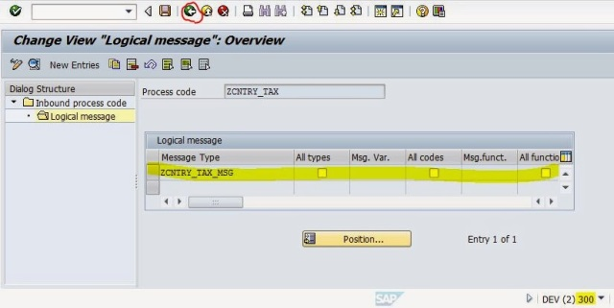](https://sapcodes.com/wp-content/uploads/2015/11/be029-99.jpg)**

**Step106. Now go to Tcode- BD64 to generate the partner profile from the Customer distribution model.**

**[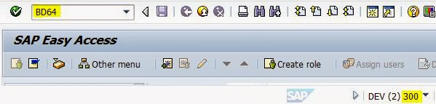](https://sapcodes.com/wp-content/uploads/2015/11/03bf1-100.jpg)**

**Step107. Select the Distribution model, From the Environment menu click on Generate Partner profile .**

**[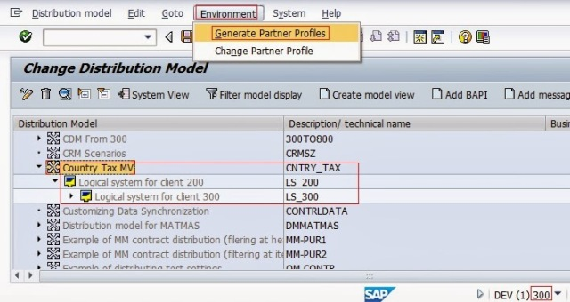](https://sapcodes.com/wp-content/uploads/2015/11/68ce3-101.jpg)**

**Step108. Execute the program.**

**[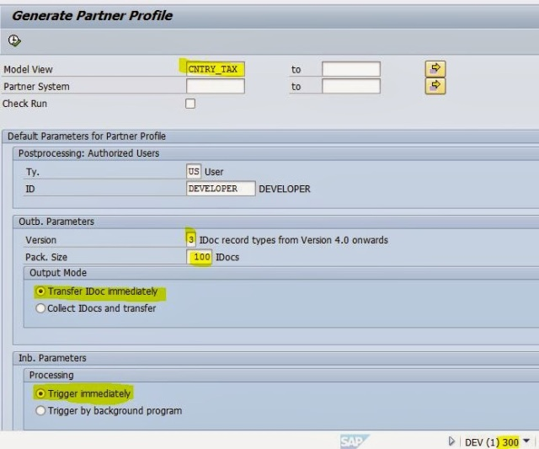](https://sapcodes.com/wp-content/uploads/2015/11/97fbf-102.jpg)**

**Step109. The partner profiles LS_200 and Ls_300 are generated.**

**[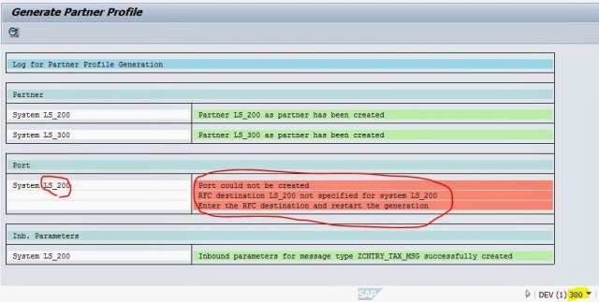](https://sapcodes.com/wp-content/uploads/2015/11/af7eb-103.jpg)**

**Step110. Now go to Tcode- WE20 to see the partner profiles.**

**[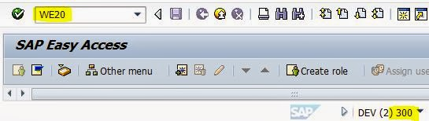](https://sapcodes.com/wp-content/uploads/2015/11/e6c3a-104.jpg)**

**Step111. Under the Partner Type ‘LS’ select the partner profile LS_200. The message type ZCNTRY_TAX_MSG is already added in the Inbound parameters section. Now click on the Add button under the Outbound parameters section.**

Advertisement

**[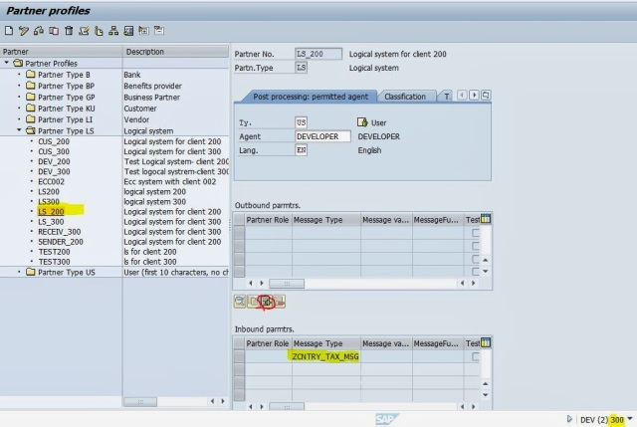](https://sapcodes.com/wp-content/uploads/2015/11/666b6-105.jpg)**

**Step112. Provide the message type, port, basic idoc type, save it and at last click on back button.**

**[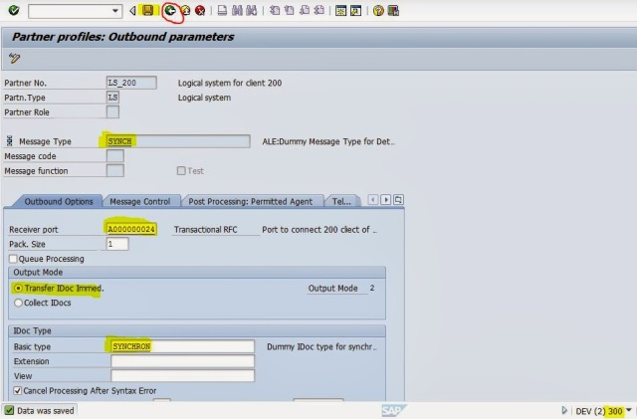](https://sapcodes.com/wp-content/uploads/2015/11/2ebf7-106.jpg)**

**Step113. Now double click on the Message type  ZCNTRY_TAX_MSG under the Inbound parameters.**

**[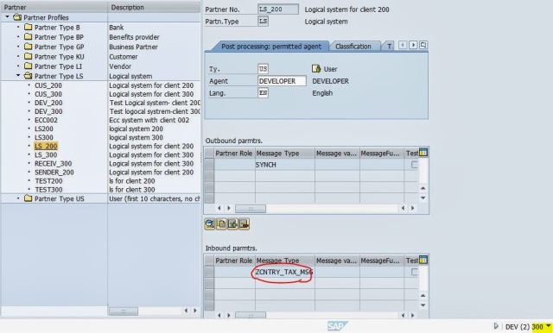](https://sapcodes.com/wp-content/uploads/2015/11/3498d-107.jpg)**

**Step114. The generated processing code is assigned to the message type.**

**[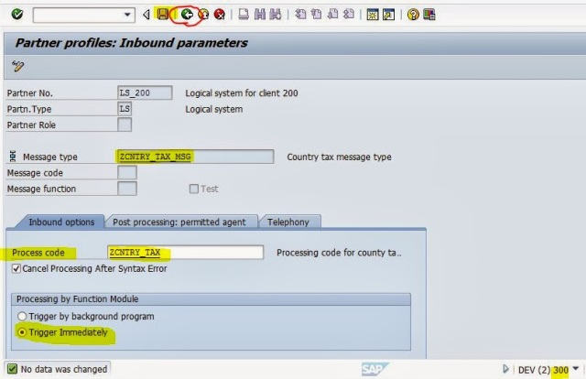](https://sapcodes.com/wp-content/uploads/2015/11/bb42c-108.jpg)**

**Step115. Now go to Tcode- BD64 to generate the partner profile from the Customer distribution model. Select the Distribution model, From the Environment menu click on Generate Partner profile . Execute the program.**

**[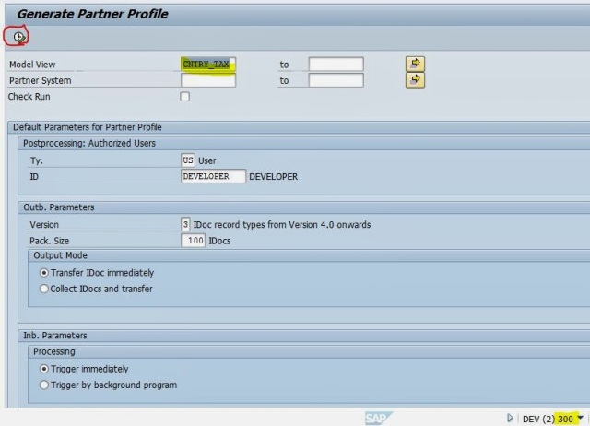](https://sapcodes.com/wp-content/uploads/2015/11/52595-109.jpg)**

**Step116. There are no red lines. So all set up is done in the client 300 to receive the Idoc.**

**[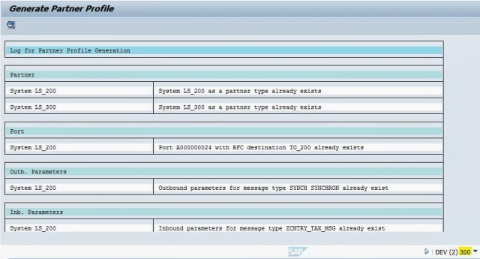](https://sapcodes.com/wp-content/uploads/2015/11/6637d-110.jpg)**

**Step117. Now go the client-200 and execute the report.**

**[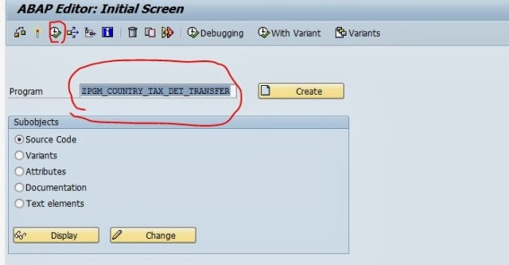](https://sapcodes.com/wp-content/uploads/2015/11/e44d3-111.jpg)**

**Step118. Provide the country name and execute it.**

**[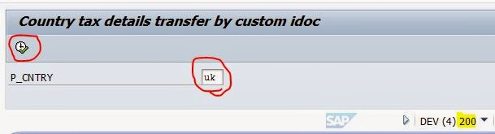](https://sapcodes.com/wp-content/uploads/2015/11/804fa-112.jpg)**

**Step119. The idoc generated 203039.**

**[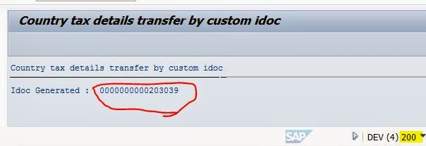](https://sapcodes.com/wp-content/uploads/2015/11/287d2-113.jpg)**

**Step120.  Again execute the report and Provide the country name and execute it.**

**[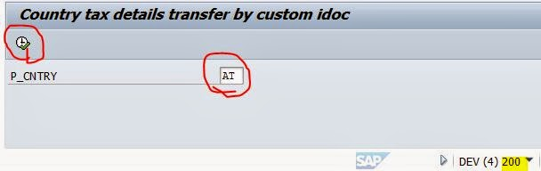](https://sapcodes.com/wp-content/uploads/2015/11/6bcd5-114.jpg)**

**Step121. The idoc generated 203040.**

**[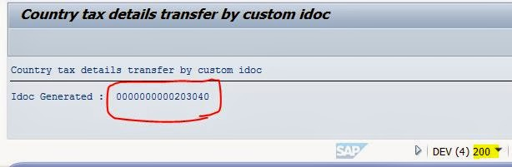](https://sapcodes.com/wp-content/uploads/2015/11/9b741-115.jpg)**

**Step122. Now go to Tcode- WE02 in the  client 200 to see the Idoc details.Provide the idoc numbers and execute it.**

**[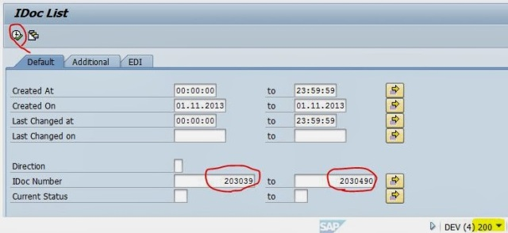](https://sapcodes.com/wp-content/uploads/2015/11/c68e1-116.jpg)**

**Step123. Now the idoc status is 30(ready for dispatch to the port). If the status is 03 then idoc is dispatched.**

**[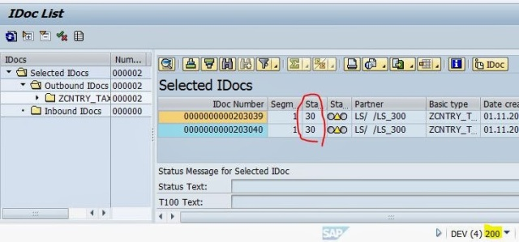](https://sapcodes.com/wp-content/uploads/2015/11/fa43c-117.jpg)**

**Step124. Go to SE38 and execute the report RSEOUT00 .**

**[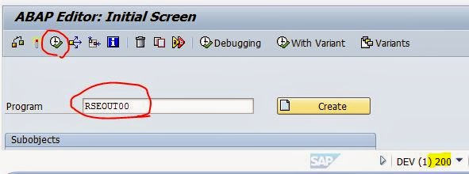](https://sapcodes.com/wp-content/uploads/2015/11/51771-118.jpg)**

**Step125. Provide the Idoc numbers and execute it.**

**[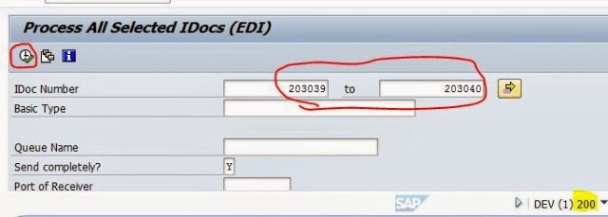](https://sapcodes.com/wp-content/uploads/2015/11/03a46-119.jpg)**

**Step126. clckc on the continue button.**

**[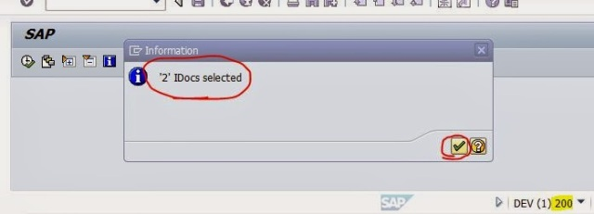](https://sapcodes.com/wp-content/uploads/2015/11/d7cf2-120.jpg)**

**Step127. Now again go to tcode- WE02 and provide the Idoc numbers and execute it.**

**[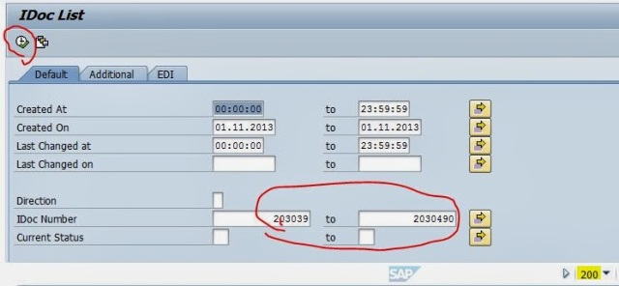](https://sapcodes.com/wp-content/uploads/2015/11/c24d4-121.jpg)**

**Step128. Now the idoc status is 03 with green status. Double click on each idoc to see the details of it.**

**[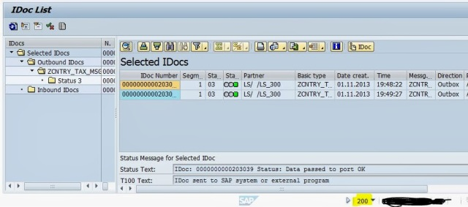](https://sapcodes.com/wp-content/uploads/2015/11/84faf-122.jpg)**

**Step129. The IDOC- 203039 contains the details as shown below.**

**[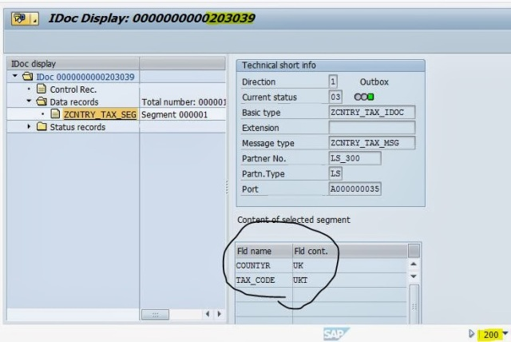](https://sapcodes.com/wp-content/uploads/2015/11/bb42d-123.jpg)**

**Step130.  The IDOC- 203040 contains the details as shown below.**

**[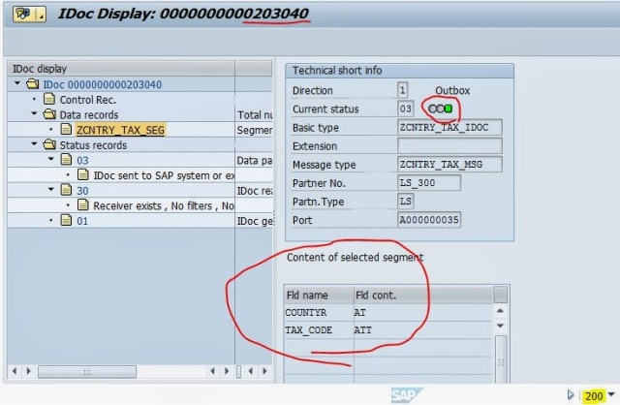](https://sapcodes.com/wp-content/uploads/2015/11/bb7f6-124.jpg)**

**Step131. Now go to code- WE02 in the client 300.**

**[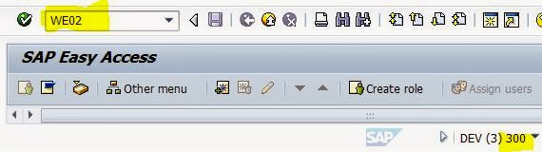](https://sapcodes.com/wp-content/uploads/2015/11/43c56-125.jpg)**

**Step132. Provide the Idoc type name and execute the report.**

**[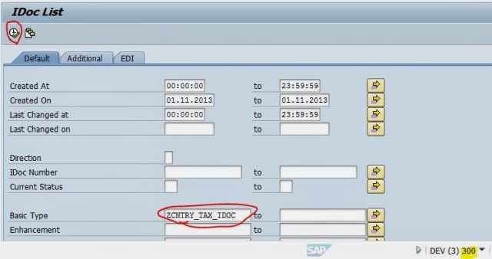](https://sapcodes.com/wp-content/uploads/2015/11/5e075-126.jpg)**

**Step133. Now the idocs are with status 56 with red status.**

**[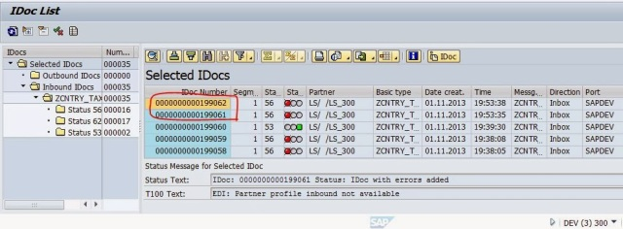](https://sapcodes.com/wp-content/uploads/2015/11/1a19b-127.jpg)**

**Step134. Go to Tcode WE19 and provide the inbound Idoc number.**

**[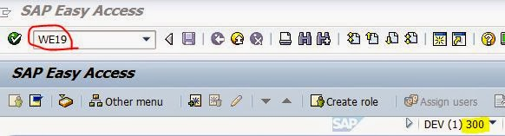](https://sapcodes.com/wp-content/uploads/2015/11/7b4cf-128.jpg)**

**Step135. Provide the Inbound Idoc number and execute it.**

**[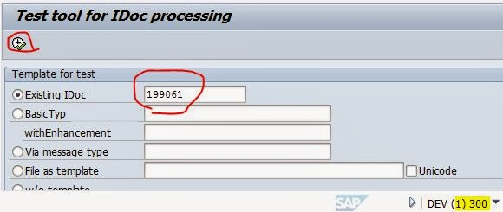](https://sapcodes.com/wp-content/uploads/2015/11/a759e-129.jpg)**

**Step136. Now click on Inbound Function Module name .**

**[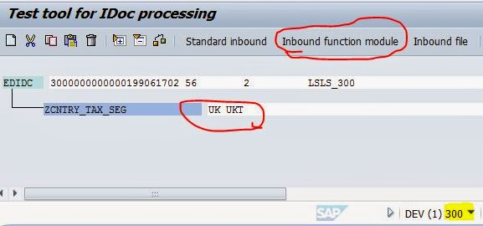](https://sapcodes.com/wp-content/uploads/2015/11/64348-130.jpg)**

**Step137. From the popup, select the Call in debugging mode check box and Select the radio button In foreground and then click on Continue button.**

Advertisement

**[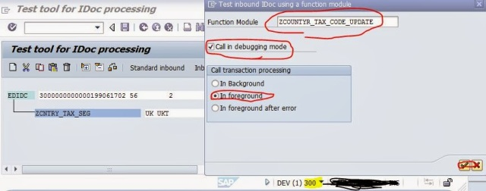](https://sapcodes.com/wp-content/uploads/2015/11/820bc-131.jpg)**

**Step138.**

**[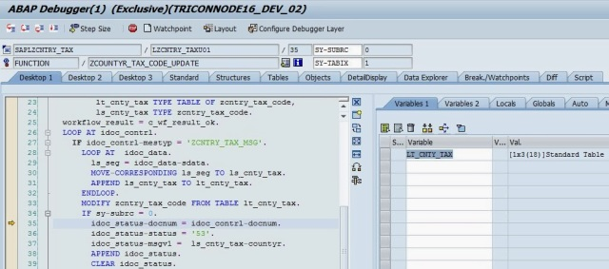](https://sapcodes.com/wp-content/uploads/2015/11/b1a32-132.jpg)**

**Step139. Now go to SE11 and open the table and go to the contents button. Provide the country name UK and execute it.**

**[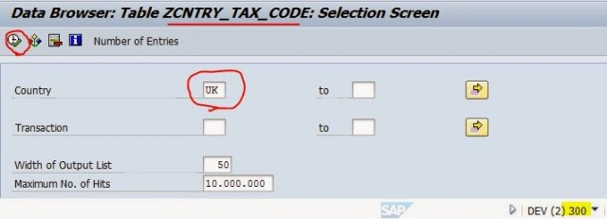](https://sapcodes.com/wp-content/uploads/2015/11/17717-133.jpg)**

**Step140. The Record is available in the client 300.**

**[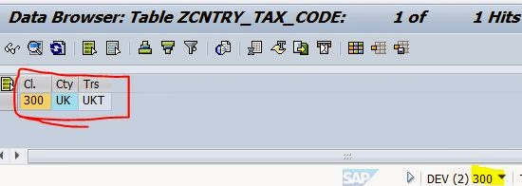](https://sapcodes.com/wp-content/uploads/2015/11/de9f4-134.jpg)**